F.5 Biology (2021-2022) Reproduction in Human

Name:_____________________________ ( ) F.5 ______ Date: _____________

Staions 1 and 2 : Male and female reproductive system.
(i) Identify the labelled structure in the model:

(1). Male reproductive system |  |  | (2.i). Female reproductive system
A |  |  | P
B |  |  | Q
C |  |  | R
D |  |  | S
E |  |  | T
F
G
H

(2.ii.) Examine the prepared slides under the microscopes, write down two structures you can identify in each of them.

Station 3: Embryonic development
- Name process L: _________________________________________________________
- Name process M:_________________________________________________________
- Write down the fates of the cells coloured
yellow: _________________________________________________________________
blue: ___________________________________________________________________
- Name structure N:_________________________________________________________
Their presence can ________________________________________________________
- Cavity O is filled with a fluid called __________________________________________
Its functions:

Station 4: foetal development
(i) Identify the labelled structure in the model showing the 7th month of pregnancy and complete the table:
(you need to remove the foetus to expose the structures)

Label | Structure | Function
X
Y
Z

(ii) Which structure contains both maternal and foetal tissues? _____________________________________
(iii) Write down a change observed during the developmental process.

Station 5: Rhythm method
- Complete the following table:
Rhythm method
Biological basis | Failure rate (%) | Possible side effects | Any limitation?
Preventing sperms from meeting the by avoiding sexual intercourse during
the period, i.e. the period of the menstrual cycle when is likely to occur.

- How could we estimate the timing of ovulation?
Method one:
By recording…______________________________________________________________
A sudden rise in basal body temperature indicates______________________________

Method two:
Some kit available in the market can detect the date of ovulation by detecting a sudden release of a hormone (luteinizing hormone) that triggers ovulation.

- Mark down on the following graph when should sexual intercourse be carried out to (i) avoid and (ii) ensure pregnancy using pen of different colours.
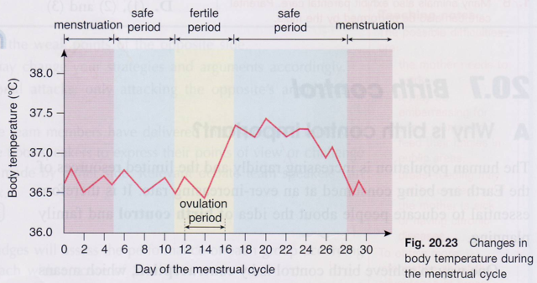

Station 6: Barrier methods
- Complete the following table:
Barrier methods
Biological basis | Failure rate (%) | Possible side effects | Give protection against STDs?
1. Condom
Preventing sperms from meeting
the by preventing sperms from entering the .
2. Diaphragm (with spermicides)
Preventing sperms from meeting
the by preventing sperms from entering the .

(ii) Why should the diaphragm be removed at least 6 hours after the sexual intercourse?

Station 6: Chemical methods
(i) Complete the following table:
Chemical methods
Biological basis | Failure rate (%) | Possible side effects | Give protection against STDs*?
1. Spermicides
Contain chemicals that kill or inactivating .
2. Contraceptive pills
Contain high dose of female sex hormones, . and ., that inhibit the release of another hormone (LH) which responsible for triggering ovulation. This prevents ovulation, no . will be released from ovaries.
- Study the instruction sheet for the male/female condoms and diaphragm provided and answer the following questions.
How could spermicide (sperm-killing cream) be used with the male/female condoms and diaphragm?

Station 7: Prevention of implantation

(i) Complete the following table:
Method to prevent implantation (a reversible/irreversible* methods)
Biological basis |  | Possible side effects  / points to note | Give protection against STDs**?
- Intra-uterine device (IUD)  Preventing the embryo from . .  (the exact mechanisms is not clearly known yet; may due to the _____________ / ______________ ______________ caused by the embedment of the foreign materials into the _______________) |  | - May cause irritation to .  - May cause heavier/longer menstrual flow  - May cause _________________bleeding.  - May cause _________________ pain.  - May increase risk of . (and thus affecting the fertility in future)  - Must be performed by _______________________.  - Can serve as emergency method and must be taken within .after the unprotected sexual intercourse.
2. Morning-after pill  Preventing the _____________ from ____________________________.  Its action is to interfere with normal hormonal signals that govern events between ovulation and implantation. |  | - May cause . .  ___________________________________.  - must be taken within hours after the unprotected sexual intercourse.  - Serves as emergency method and is only available on prescription from a doctor.

- The diagrams below show the male and female reproductive structures. Mark down on the diagram the correct positions where the IUD should be operated.
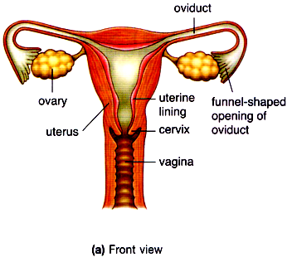

Station 8: Surgical methods (sterilisation)

- Complete the following table:
Surgical methods (sterilisation) (a reversible/irreversible* methods)
Biological basis | Failure rate (%) | Possible side effects | Is there production of gametes?
1. Male sterilisation (vasectomy)  Preventing sperms from meeting the . by . and . the vas deference (i.e. sperm ducts).  2. Female sterilisation (tubal ligation)  Preventing sperms from meeting the ovum by cutting and tying the .. |  | .  (P.S.: the cut ends of the sperm ducts/oviducts may rejoin in some cases, though very rare).

- Explain why a man’s sexual ability will not be affected after vasectomy.

- Explain whether a woman can have normal menstruation after tubal ligation.

- The diagrams below show the male and female reproductive structures. Mark down on the diagram the correct positions where the vasectomy and tubal ligation should be operated.
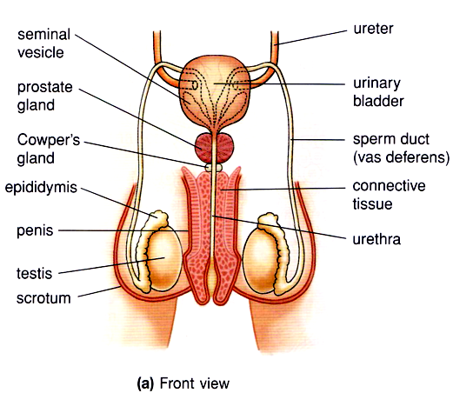

Study cases of two couples below:

Couple 1
We are Mr. and Mrs. Bean. We have just got married and do not plan to have our baby in the coming three to four years due to economic difficulty. We are not sure whether we will want to have our baby later on.


Tick the contraceptive method suggested to the couple:

rhythm method |  | diaphragm (with spermicide)
male condom (with spermicide) |  | contraceptive pills
female condom (with spermicide) |  | tubal ligation
IUD |  | vasectomy

Couple 2
We are Mr. and Mrs. Peanuts. We have got married for 15 years and already have three sons and one daughter. We do not plan to have more children in the future.




Tick the contraceptive method suggested to the couple:

rhythm method |  | diaphragm (with spermicide)
male condom (with spermicide) |  | contraceptive pills
female condom (with spermicide) |  | tubal ligation
IUD |  | vasectomy

Human Reproduction Lab Stations (2021-2022)
Station 1 | Male reproductive system model | Label A-H, testis, epididymis,  Sperm duct, prostate gland, Cowper’s gland, seminal vesicle, urethra urinary bladder
Station 2 | Female reproductive system model  Chart showing ovarian and menstrual cycle  2 microscopes slides:  Slide showing testis  Slide showing ovary | Label P-T: ovary, oviduct, uterus, cervix, vagina
Station 3 | Embryonic development model | Label process L (fertilization), M (mitotic cell division)  Structure N (villus), Cavity O (amniotic cavity)
Station 4 | Models showing foetal development  Gastation calculator | Label X (amnion), Y (umbilical cord), Z (placenta)
Station 5 | Rhythm method  Graph, thermometer
Station 6 | Barrier method  Male condom  Female condom  Diaphragm  Lubricant gel
Chemical method
Various kinds of spermicide
Contraceptive pills
Contraceptive injection

Station 7 | Prevent implantation  IUD  Morning after pills
Station 8 | Surgical method  Case studies

